**Treasure Island, Chapter 1 vocab**

year of grace: year in the Christian era; year A.D.

Cove: an inlet, usually with high cliffs that can protect ships from the wind

Capstan: machine for putting force on ropes, usually on a ship

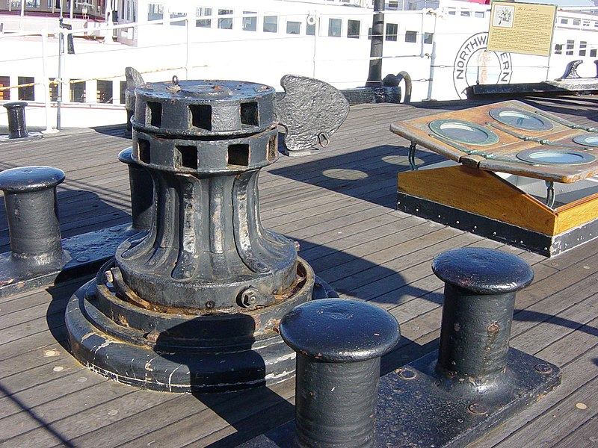

Grog: rum and water

"sittyated" - situated

"mought" - might

berth - bunk for sleeping (usually on a ship); also, room for movement: *to give someone a wide berth* means to avoid them

keep a weather eye open - be alert (a weather eye was a tool for predicting the weather)

assizes - court hearing

be quit of - be rid of in modern English

rheumatics - rheumatism